Best completed before attending sessions

Leadership Team Action Planning Worksheet

School/District/State Name: | Date: | Notetaker:
Team Members:

The purpose of this worksheet is to guide leadership teams in their development, evaluation, and updating of their implementation action plans. The following general steps should be considered:

Step 1: During team preparation, identify current implementation activities and what individual team members should bring back to the team planning process (Step 3).
Step 2: Review session topics and assign 1-2 team members to attend identified sessions and complete the Individual Team Member Note-Taking Worksheet (last page).
Step 3: During team follow-up planning meetings, use the Note-Taking Worksheet to (a) report to your team what you’ve learned, and (b) work with your team to update your PBIS/MTSS implementation action plan.
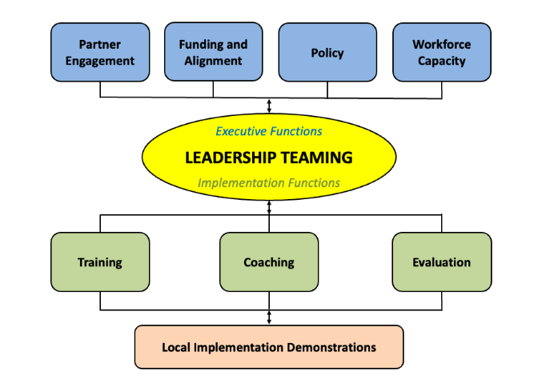
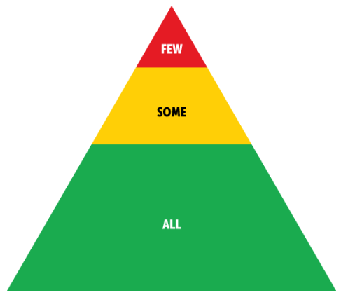
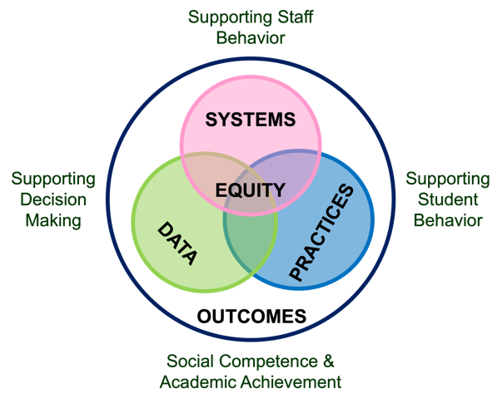

STEP 1: Action Plan Self-Assessment
What have we done/accomplished so far and what is high priority for our action planning?

Current Implementation Activities | Current Outcome Data | Fidelity or Accuracy of Implementation | Progress to Date | Priority for Action Planning | Assigned Team Member
1. |  | High Med Low | High Med Low | High Med Low
2. |  | High Med Low | High Med Low | High Med Low
3. |  | High Med Low | High Med Low | High Med Low
4. |  | High Med Low | High Med Low | High Med Low
5. |  | High Med Low | High Med Low | High Med Low
6. |  | High Med Low | High Med Low | High Med Low

STEP 2: Assign Team Members to High Priority Content Sessions
What sessions should we attend?

Team Member | Thursday  Strand | Friday Sessions
Team Member | Thursday  Strand | Breakout Sessions 4 | Breakout Sessions 5 | Breakout Sessions 6

Step 3: What Should We Do To Enhance Our Action Plan for Implementation?
How can we use what we learned to improve/enhance what we are doing?

What did we learn? | What do we want to accomplish? | How can we accomplish it? | When would we like to accomplish it? | Who will do it?

